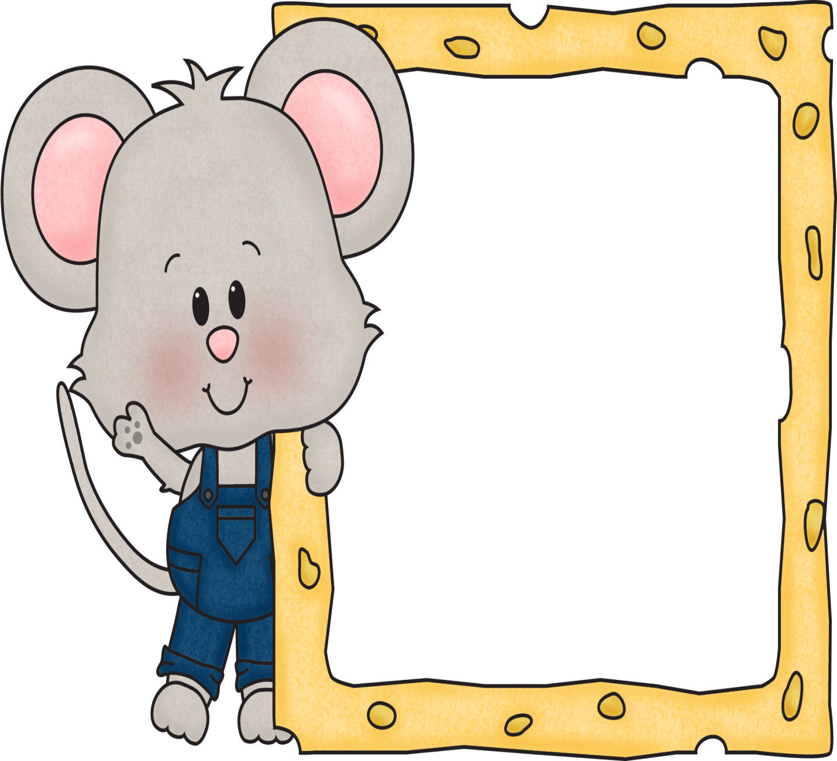

Zero Property of Multiplication:
“Anything times zero equals zero.”
1 x 0 = 0 0 x 15 = 0 0 x 6 = 0

Identity Property of Multiplication:
“Anything times 1 stays that same number.”
0 x 1 = 0 1 x 1 = 1 2 x 1 = 2
3 x 1 = 3 4 x 1 = 4 5 x 1 = 5
6 x 1 = 6 7 x 1 = 7 8 x 1 = 8
9 x 1 = 9 10 x 1 = 10 11 x 1 = 11
12 x 1 = 12

MONDAY  My child practiced their multiplication facts for at least five minutes today:  Date: ________________  Parent signature: ______________ | TUESDAY  My child practiced their multiplication facts for at least five minutes today:  Date: ________________  Parent signature: ______________
WEDNESDAY  My child practiced their multiplication facts for at least five minutes today:  Date: ________________  Parent signature: ______________ | THURSDAY  My child practiced their multiplication facts for at least five minutes today:  Date: ________________  Parent signature: ______________

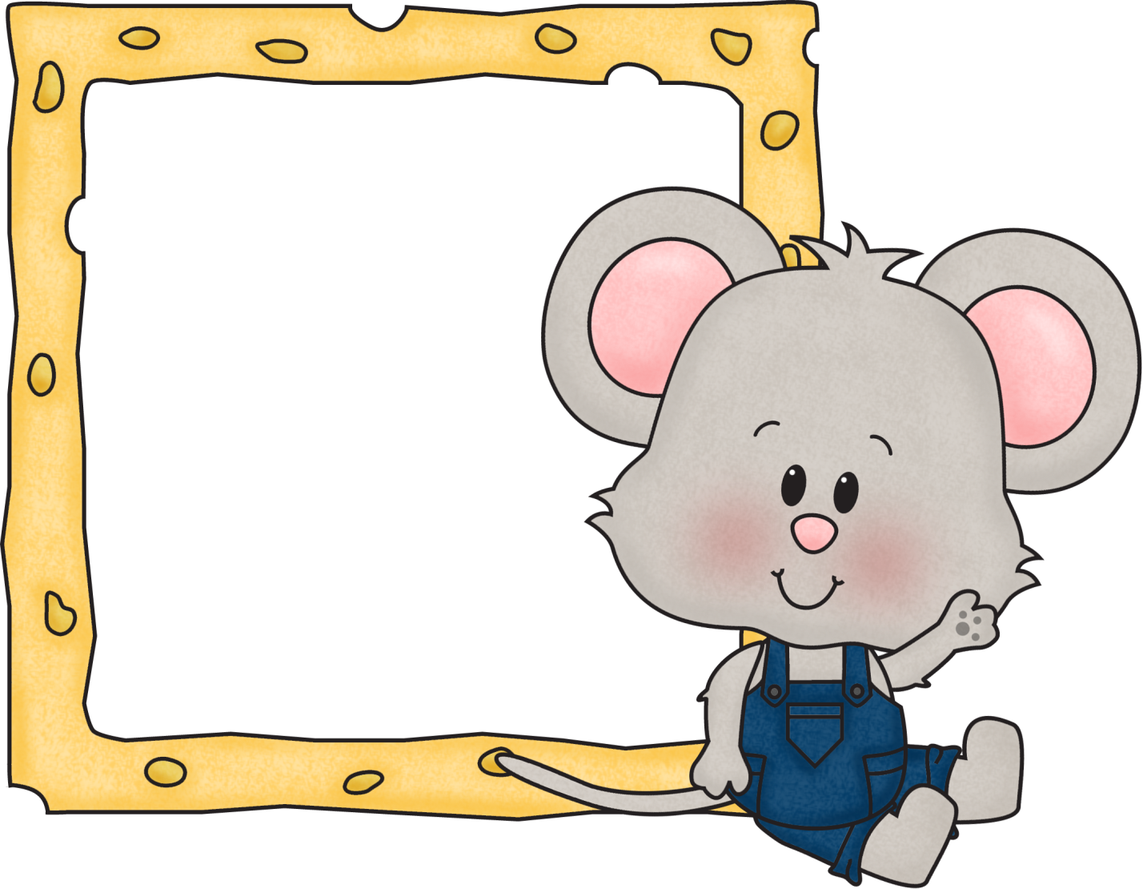

0 X 2 = 0 7 X 2 = 14
1 X 2 = 2 8 X 2 = 16
2 X 2 = 4 9 X 2 = 18
3 X 2 = 6 10 X 2 = 20
4 X 2 = 8 11 X 2 = 22
5 X 2 = 10 12 X 2 = 24
6 X 2 = 12

MONDAY  My child practiced their multiplication facts for at least five minutes today:  Date: ________________  Parent signature: ______________ | TUESDAY  My child practiced their multiplication facts for at least five minutes today:  Date: ________________  Parent signature: ______________
WEDNESDAY  My child practiced their multiplication facts for at least five minutes today:  Date: ________________  Parent signature: ______________ | THURSDAY  My child practiced their multiplication facts for at least five minutes today:  Date: ________________  Parent signature: ______________

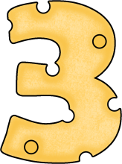

0 X 3 = 0 7 X 3 = 21
1 X 3 = 3 8 X 3 = 24
2 X 3 = 6 9 X 3 = 27
3 X 3 = 9 10 X 3 = 30
4 X 3 = 12 11 X 3 = 33
5 X 3 = 15 12 X 3 = 36
6 X 3 = 18

MONDAY  My child practiced their multiplication facts for at least five minutes today:  Date: ________________  Parent signature: ______________ | TUESDAY  My child practiced their multiplication facts for at least five minutes today:  Date: ________________  Parent signature: ______________
WEDNESDAY  My child practiced their multiplication facts for at least five minutes today:  Date: ________________  Parent signature: ______________ | THURSDAY  My child practiced their multiplication facts for at least five minutes today:  Date: ________________  Parent signature: ______________

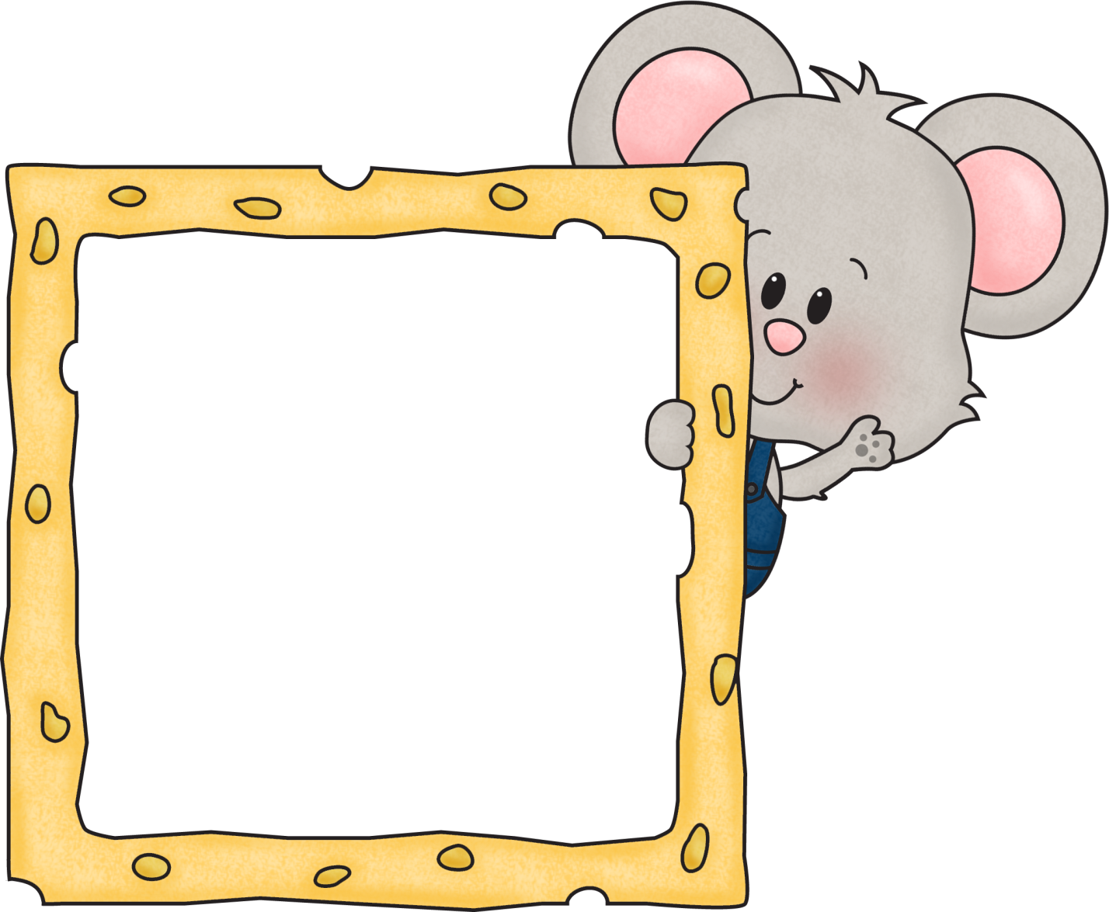

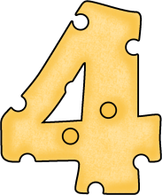

0 X 4 = 0 7 X 4 = 28
1 X 4 = 4 8 X 4 = 32
2 X 4 = 8 9 X 4 = 36
3 X 4 = 12 10 X 4 = 40
4 X 4 = 16 11 X 4 = 44
5 X 4 = 20 12 X 4 = 48
6 X 4 = 24

MONDAY  My child practiced their multiplication facts for at least five minutes today:  Date: ________________  Parent signature: ______________ | TUESDAY  My child practiced their multiplication facts for at least five minutes today:  Date: ________________  Parent signature: ______________
WEDNESDAY  My child practiced their multiplication facts for at least five minutes today:  Date: ________________  Parent signature: ______________ | THURSDAY  My child practiced their multiplication facts for at least five minutes today:  Date: ________________  Parent signature: ______________

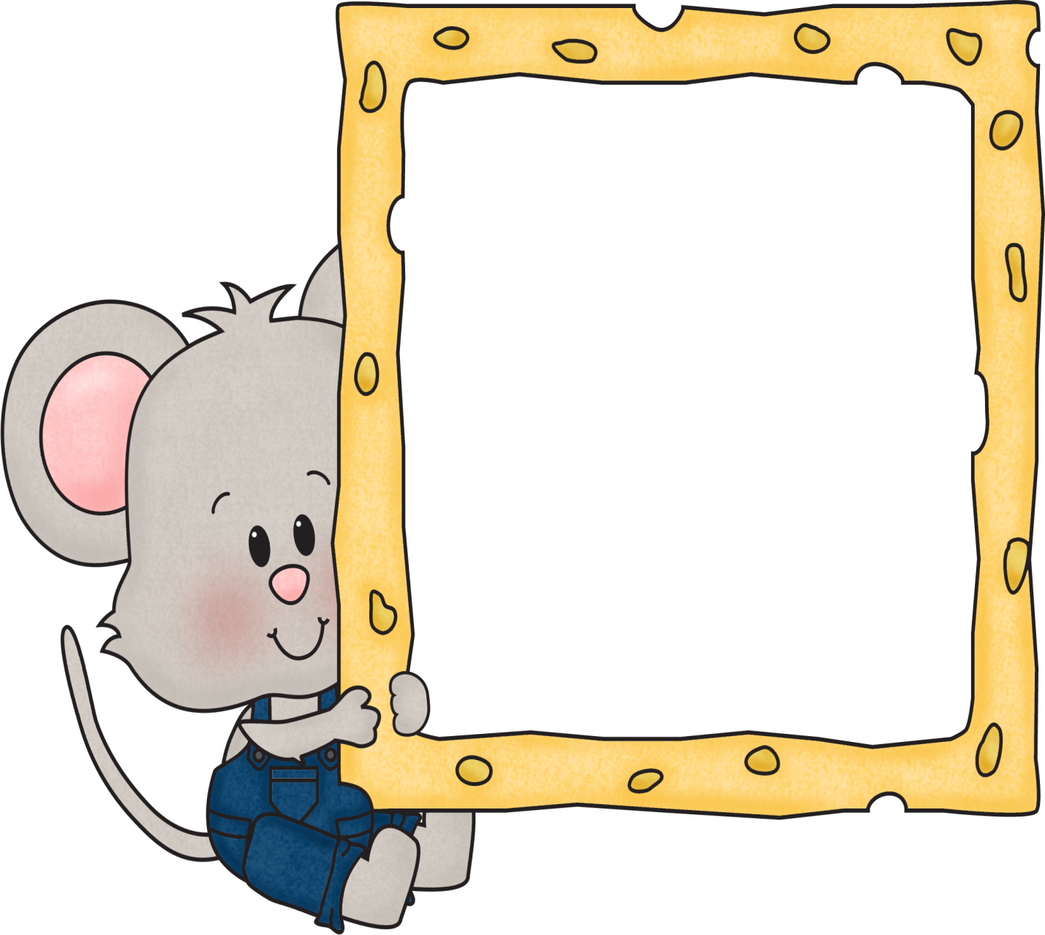

0 X 5 = 0 7 X 5 = 35
1 X 5 = 5 8 X 5 = 40
2 X 5 = 10 9 X 5 = 45
3 X 5 = 15 10 X 5 = 50
4 X 5 = 20 11 X 5 = 55
5 X 5 = 25 12 X 5 = 60
6 X 5 = 30

MONDAY  My child practiced their multiplication facts for at least five minutes today:  Date: ________________  Parent signature: ______________ | TUESDAY  My child practiced their multiplication facts for at least five minutes today:  Date: ________________  Parent signature: ______________
WEDNESDAY  My child practiced their multiplication facts for at least five minutes today:  Date: ________________  Parent signature: ______________ | THURSDAY  My child practiced their multiplication facts for at least five minutes today:  Date: ________________  Parent signature: ______________

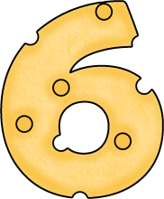

0 X 6 = 0 7 X 6 = 42
1 X 6 = 6 8 X 6 = 48
2 X 6 = 12 9 X 6 = 54
3 X 6 = 18 10 X 6 = 60
4 X 6 = 24 11 X 6 = 66
5 X 6 = 30 12 X 6 = 72
6 X 6 = 36

MONDAY  My child practiced their multiplication facts for at least five minutes today:  Date: ________________  Parent signature: ______________ | TUESDAY  My child practiced their multiplication facts for at least five minutes today:  Date: ________________  Parent signature: ______________
WEDNESDAY  My child practiced their multiplication facts for at least five minutes today:  Date: ________________  Parent signature: ______________ | THURSDAY  My child practiced their multiplication facts for at least five minutes today:  Date: ________________  Parent signature: ______________
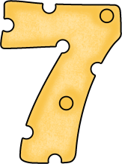
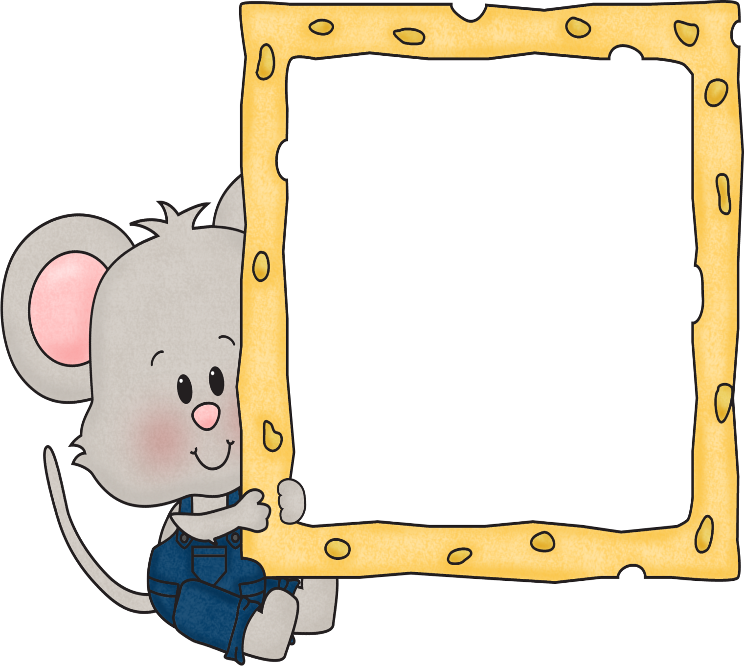

0 X 7 = 0 7 X 7 = 49
1 X 7 =7 8 X 7 = 56
2 X 7 = 14 9 X 7 = 63
3 X 7 = 21 10 X 7 = 70
4 X 7 = 28 11 X 7 = 77
5 X 7 = 35 12 X 7 = 84
6 X 7 = 42

MONDAY  My child practiced their multiplication facts for at least five minutes today:  Date: ________________  Parent signature: ______________ | TUESDAY  My child practiced their multiplication facts for at least five minutes today:  Date: ________________  Parent signature: ______________
WEDNESDAY  My child practiced their multiplication facts for at least five minutes today:  Date: ________________  Parent signature: ______________ | THURSDAY  My child practiced their multiplication facts for at least five minutes today:  Date: ________________  Parent signature: ______________

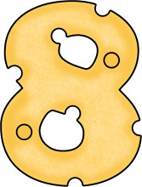

0 X 8 = 0 7 X 8 = 56
1 X 8 = 8 8 X 8 = 64
2 X 8 = 16 9 X 8 = 72
3 X 8 = 24 10 X 8 = 80
4 X 8 = 32 11 X 8 = 88
5 X 8 = 40 12 X 8 = 96
6 X 8 = 48

MONDAY  My child practiced their multiplication facts for at least five minutes today:  Date: ________________  Parent signature: ______________ | TUESDAY  My child practiced their multiplication facts for at least five minutes today:  Date: ________________  Parent signature: ______________
WEDNESDAY  My child practiced their multiplication facts for at least five minutes today:  Date: ________________  Parent signature: ______________ | THURSDAY  My child practiced their multiplication facts for at least five minutes today:  Date: ________________  Parent signature: ______________

MONDAY  My child practiced their multiplication facts for at least five minutes today:  Date: ________________  Parent signature: ______________ | TUESDAY  My child practiced their multiplication facts for at least five minutes today:  Date: ________________  Parent signature: ______________
WEDNESDAY  My child practiced their multiplication facts for at least five minutes today:  Date: ________________  Parent signature: ______________ | THURSDAY  My child practiced their multiplication facts for at least five minutes today:  Date: ________________  Parent signature: ______________

0 X 9 = 0 7 X 9 = 63
1 X 9 = 9 8 X 9 = 72
2 X 9 = 18 9 X 9 = 81
3 X 9 = 27 10 X 9 = 80
4 X 9 = 36 11 X 9 = 99
5 X 9 = 45 12 X 9 = 108
6 X 9 = 54

MONDAY  My child practiced their multiplication facts for at least five minutes today:  Date: ________________  Parent signature: ______________ | TUESDAY  My child practiced their multiplication facts for at least five minutes today:  Date: ________________  Parent signature: ______________
WEDNESDAY  My child practiced their multiplication facts for at least five minutes today:  Date: ________________  Parent signature: ______________ | THURSDAY  My child practiced their multiplication facts for at least five minutes today:  Date: ________________  Parent signature: ______________

MONDAY  My child practiced their multiplication facts for at least five minutes today:  Date: ________________  Parent signature: ______________ | TUESDAY  My child practiced their multiplication facts for at least five minutes today:  Date: ________________  Parent signature: ______________
WEDNESDAY  My child practiced their multiplication facts for at least five minutes today:  Date: ________________  Parent signature: ______________ | THURSDAY  My child practiced their multiplication facts for at least five minutes today:  Date: ________________  Parent signature: ______________

MONDAY  My child practiced their multiplication facts for at least five minutes today:  Date: ________________  Parent signature: ______________ | TUESDAY  My child practiced their multiplication facts for at least five minutes today:  Date: ________________  Parent signature: ______________
WEDNESDAY  My child practiced their multiplication facts for at least five minutes today:  Date: ________________  Parent signature: ______________ | THURSDAY  My child practiced their multiplication facts for at least five minutes today:  Date: ________________  Parent signature: ______________

