ARRAYS ARE EVERYWHERE!
An assignment for students and parents
In math, we have been learning about arrays as we start our multiplication unit. I want students to recognize that the math concepts they learn in school have real-world applications, so I am sending your child on the hunt for an array!
- Please take some time to talk with your child about arrays. Your child should be able to explain to you what an array is and how they relate to multiplication.
- Together, think about an array that can be found “in the real world,” be it around the house, at the grocery store, or outside. For example, an egg carton is an example of a real-world array (it has two rows, with 6 eggs in each row).
- Have your child take a picture of the real-world array and email it to me at: avolk@southcountry.org . We will be using the photographs for a variety of activities in class. Rather than emailing the picture, you can always print it out and send it in with your child.

Please feel free to contact me if you have any questions or need a hint about where to find a real-life example of an array. Thank you for your cooperation!

Please email or send in the picture by Wednesday, November 21st.

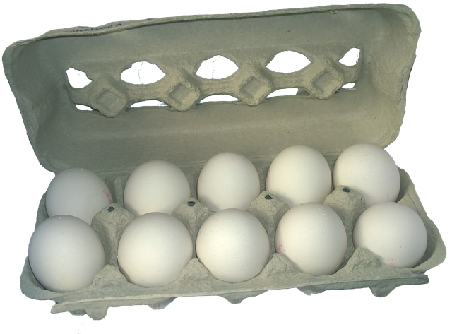
2 rows of 6 eggs
2 groups of 6
6 + 6 = 12
2 x 6 = 12

